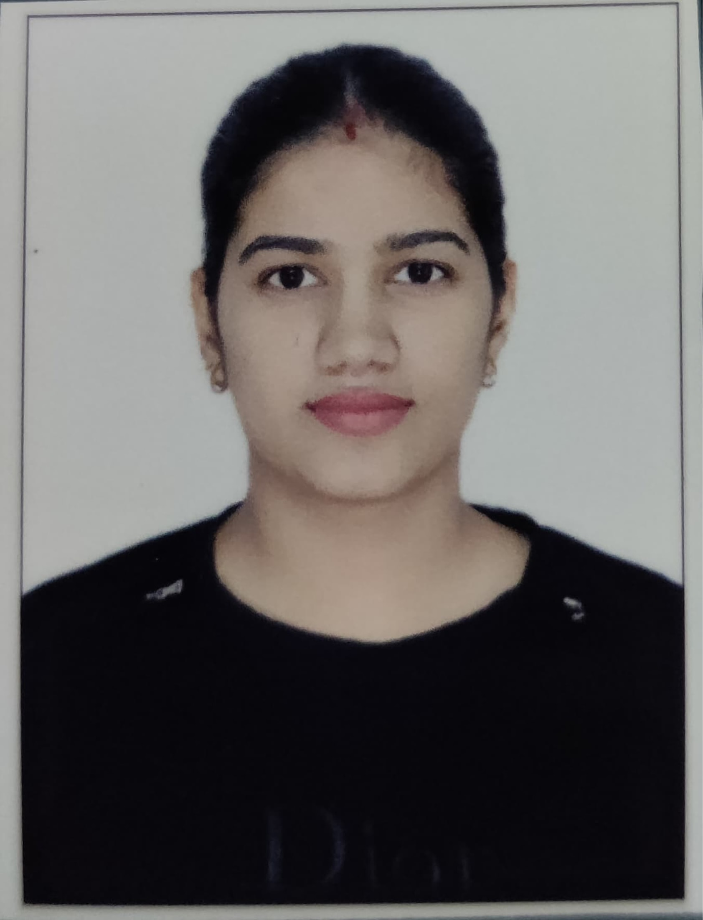

# Mansi Yadav

**Contact- 9717120095**

**E-mail**- [mansiyadav342@gmail.com](mailto:mansiyadav342@gmail.com)

**APPLY FOR THE POST OF - PRT AND TGT (SOCIAL SCIENCE )**

Career Objective

My objective is to work in a dynamic environment that provides me a wide spectrum to experience and exposure. Also wish to perpetuate a career where I can interact with people and learn their experience to attain a position of strength and satisfaction within the organization.

# Key Skills

**Technical skills:** MsWord, Excel, MS Office.

**Management Skills:** Leadership, time management, Problem solving, social media marketing

**Competency**

* Great communication skill & bold approach to creating effective lesson plans.
* An enthusiastic educator who understand for students to gain physical skills and objective .

# 

# Academic Qualification

|  |  |  |  |  |
| --- | --- | --- | --- | --- |
| **Year** | **Degree** | **School/Institute** | **Board/University** | **Percentage/GP A** |
| 2022 | B.ed | RASTRIYA VIDYA EDUCATION COLLEGE | GURGRUGRAM UNIVERSITY | PERSUING |
| 2022 | MASTER IN  POLITICAL SCIENCE | IGNOU | IGNOU UNIVERSITY | 51.76% |
| 2020 | BA | GARGI COLLEGE | DELHI UNIVERSITY | 6.348 |
| 2017 | 12th | SOLDIER PUBLIC SCHOOL, GURUGRAM | CBSE | 75% |
| 2015 | 10th | SOLDIER PUBLIC  SCHOOL, GURUGRAM | CBSE | 70% |

**Hobbies**

* Traveling
* Love to cook.
* Arts and craft
* Designing
* Playing basket ball

# Experience

* Worked as a manager at Navuday fuels for 10 months
* Teached as a tution teacher of local village students upto class 8th for 2 years.

**Declaration**

I hereby declare that all the details furnished above are true to the best of my knowledge and belief .

Date : 1.01.2023

Gurgaon

Mansi Yadav